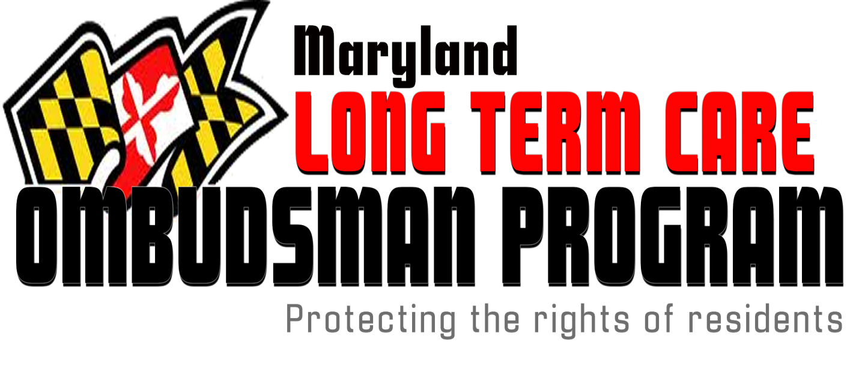

MARYLAND LONG TERM CARE OMBUDSMAN PROGRAM (LTCOP)
Volunteer Application

Name: __________________________________________ Email: ____________________

Address: _____________________________________________________________________

Home Phone: ( ) _________ Work Phone: ( ) _________ Cell Phone: ( ) __________
(Please circle preferred telephone number)

Are you age 21 or over? Yes_________ No__________

Education: High School ____ College ____ Graduate Degree ____ Tech Training _________

Field of Study: _________________________________________________________________

Why do you want to become a volunteer for the Long Term Care Ombudsman Program?
_______________________________________________________________________________
_______________________________________________________________________________
_______________________________________________________________________________

Employment Experience: (Describe skills and duties –Include resume)
______________________________________________________________________________
______________________________________________________________________________
______________________________________________________________________________
________________________________________________________________________

Have you had any experience with Long Term Care Residents and/or Older Adults? Please
describe. ________________________________________________________________
________________________________________________________________________
________________________________________________________________________

What experience have you had with a Nursing Home or Assisted Living Facility? In what capacity? _______________________________________________________________________________
_______________________________________________________________________________
_______________________________________________________________________________

How did you learn about volunteering with the LTCO Program? Newspaper ad __ LTCOP Staff __
LTCOP volunteer __ brochure __ flyer __ Web site __ other _____________________________

What languages do you speak? ____________________________________

Do you drive or have reliable transportation? Yes ___ No _____

Do you have any relatives or friends closely connected with, employed by, or currently living in a nursing home or assisted living facility? If yes, please explain. ___________________________________________________________________________________
___________________________________________________________________________________
___________________________________________________________________________________

Please provide the name and phone number of a person we should notify in the event of an emergency.

Name: ___________________________________ Relationship: ____________________________
Address ___________________________________________________________________________
City: ___________________________________ State: ________________________ Zip: _______
Phone Number(s): __________________________________________________________________

Please list two non-family references we may contact, such as teachers, employers or community members:
Name: _______________________________ Tel #: ___________________
Relationship to you: ______________________________________________

Name: _______________________________ Tel # ___________________
Relationship to you: ______________________________________________

This position requires working with vulnerable adults so we may need to do a criminal background check. Would you grant permission? Yes ___ No ___

SIGNATURE: _______________________________________ DATE: _________________________

Thank you for your interest in volunteering for the Long Term Care Ombudsman Program. Please send this form to the Volunteer Developer and she will forward it to the appropriate program.
Phyllis Meyerson, Volunteer Developer
13412 Green Hills Ct
Highland MD 20777

OR call Ombudsman Program at the Maryland Dept. of Aging 410-767-1100

