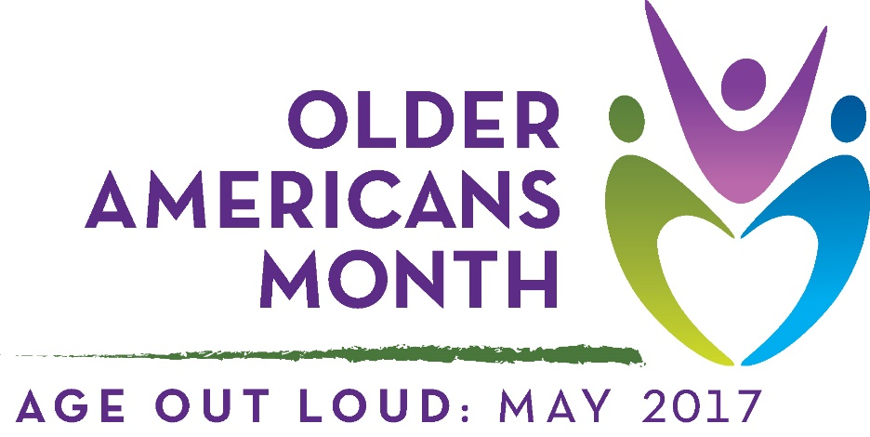

Event Name: 15th Annual Senior Summit
Event Location: Queen Anne’s County 4-H Park (4-H Park Road, Centreville, MD 21617)
Number of seniors expected/ attended: 350
Brief Description/Announcement: See Attached Flyer
Interviews/stories/participant feedback: N/A
Images: See Second Page
