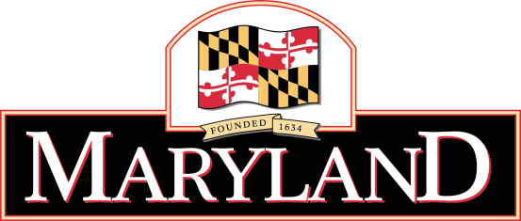
Larry Hogan

Governor

Boyd K. Rutherford

Lt. Governor

Rona E. Kramer
Secretary

DEPARTMENT OF AGING

Below are some specific ideas and suggestions for ways to implement National Healthcare Decisions Day (NHDD) activities in your community and at your AAA

First and foremost, lead by example…be sure you have thoughtfully considered and made your own healthcare decisions known.

Community Initiatives
- Make sure everyone in your organization is informed about NHDD (including staff, board of directors, volunteers and others) and ask for their involvement to promote NHDD in your community. (Suggestion: Have staff wear a sticker that says “Ask Me About Advance Directives!” See sticker template located above in the Outreach Resources section.)
- Set up an exhibit about NHDD at your main entrance and offer information about advance care planning as people come by.
- Partner with other local organizations to promote NHDD. You will reach and benefit more people if you do this with others than alone!
- Partner with local retail businesses by asking them to place a promotional flyer about NHDD in every bag.
- Partner with your community library to set up a display highlighting books about advance healthcare decision-making and use NHDD promotional resources.
- Distribute NHDD promotional materials and advance care planning educational brochures at upcoming community events or health fairs.
- Offer to provide a guest-speaker on health-related radio or TV programs about advance care planning and NHDD.
- Set up exhibit tables at your local malls, pharmacies, grocery stores, or other locations to provide information about advance care planning and advance directives.
- Give a presentation to community organizations (i.e. Rotary Club, senior centers, workplace settings, faith communities, libraries, patient or family support groups, neighborhood associations) and to the public promoting NHDD and offering advance care planning resources.
- Sponsor a community event or “town hall’ meeting about advance care planning. Big events are more likely to generate media coverage than small presentations and they offer an opportunity for more in-depth dialogue with your community. (Suggestion: Ask your local bar association and healthcare organizations for volunteer speakers and/or ask local politicians to attend and publicly sign their own advance directive.)
Publicity/media outreach
- Provide a link on your organizational Web site to www.nhdd.org . This is a national Web site with a variety of information for the public and providers on advance care planning.
- Mention NHDD in your organization's/facility's telephone on-hold recording.
- Send out a press release about your NHDD activities and/or events to your local media.
- Publish an Op Ed, letter to the editor or a feature story about the importance of advance care planning in your local newspaper.
- Distribute flyers about NHDD in local physician offices and other strategic locations such as elevators in public buildings.
- Print advertisements in your local newspaper or other local publications, resource guides and newsletters about NHDD activities. (Suggestion: Ask to print the advertisements as public service announcements and see if they will also publish a copy of your state’s advance directive form.)
- Distribute information to patients at healthcare facilities with their mid-day meal.
- Encourage your state leaders to establish a state-sanctioned, secure on-line advance directive registry.

Be creative about the topic of advance care planning

