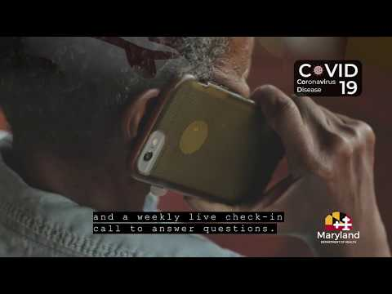
Thank you for helping to spread the word about the Maryland Department of Aging’s programs. Having supporters like yourself to advocate for programs and share information will help to elevate our messaging and in-turn help our senior population and beyond.
The Maryland Department of Aging is excited to share the news about a recently launched program called Maryland Senior Call Check. Maryland is the first state in the country to start a FREE, opt-in, telephonic service to check on Maryland’s older residents, all across the state.
We need your help spreading the word with Maryland Residents - particularly those living alone over 65 years of age. The program is designed for seniors living alone to check on them daily. This free service will place an automated daily call to the participant at a regularly scheduled time. If the call is not picked up after three attempts, the service will call an alternate person on your behalf to check on you. If your alternate does not pick up or you do not have an alternate, we will contact the local authority to perform a wellness check.
***ATTENTION IN RESPONSE TO THE COVID-19 PANDEMIC***
We recommend all seniors use the program as a resource during the COVID-19 global pandemic. Senior Call Check phone lines are open M-F 8 am-5 pm and Saturday 9 am-3 pm. During these hours, seniors can call toll-free 1-866-50-CHECK (1-866-502-0560) or register online at aging.maryland.gov.
• The verification and enrollment process can be completed within 24 hours Monday – Saturday.
• We will provide messages and updates regarding the COVID-19 outbreak.
• Finally, regarding our emergency preparedness for handling possible disruption from COVID-19, we can provide you information at this time of need.
Here are some resources to help promote “Maryland Senior Call Check.”
Website:
https://aging.maryland.gov/Pages/senior-call-check.aspx
Marketing Materials:
Brochure: https://aging.maryland.gov/SiteAssets/Pages/senior-call-check/Maryland-Senior-Call-Check-Brochure.pdf
Poster: https://aging.maryland.gov/SiteAssets/Pages/senior-call-check/Maryland-Senior-Call-Check-Poster.pdf
Videos to share:
https://youtu.be/4d1Lo23R_Wc
https://youtu.be/2orzt2P82f4

Social Image card (right click to download):
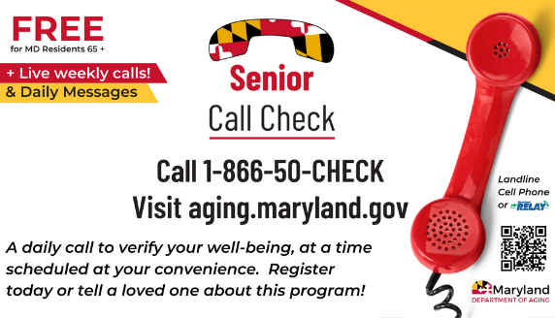
Suggested copy:
Senior Call Check is a FREE service available to adults 65+ in Maryland. Receive an automated daily call at a time you designate. After 3 attempts and no answer, we will contact your alternate person to check on you. During the pandemic, we are providing daily automated messages and live weekly calls. Registration is easy – online or over the phone!
https://aging.maryland.gov/Pages/senior-call-check.aspx
Twitter Copy:
Senior Call Check is a FREE service available to adults 65+ in #Maryland. Receive an automated daily call at a time you designate. After 3 attempts and no answer, we will contact your alternate person to check on you. Registration is easy! #marylandaging https://aging.maryland.gov/Pages/senior-call-check.aspx

