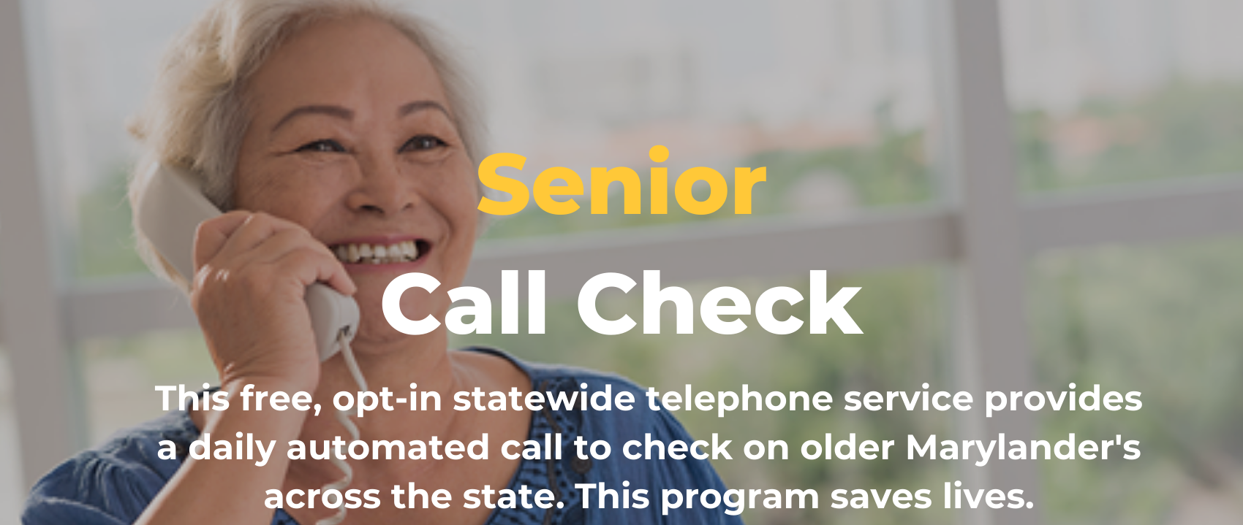
Thank you for helping to spread the word about the Maryland Department of Aging’s programs. Having supporters like yourself to advocate for programs and share information will help to elevate our messaging and in-turn help our senior population and beyond.
The Maryland Department of Aging is excited to share the news about a recently launched program called Maryland Senior Call Check. Maryland is the first state in the country to start a FREE, opt-in, telephonic service to check on Maryland’s older residents, all across the state.
We need your help spreading the word with Maryland Residents - particularly those living alone over 65 years of age. The program is designed for seniors living alone and saves lives!!! This free service will place an automated daily call to you at a regularly scheduled time. If the call is not picked up after three attempts, the service will call an alternate person on your behalf to check on you.
Here are some resources to help promote “Maryland Senior Call Check.”
Website:
https://aging.maryland.gov/Pages/senior-call-check.aspx
Marketing Materials:
Brochure: https://aging.maryland.gov/SiteAssets/Pages/senior-call-check/Maryland-Senior-Call-Check-Brochure.pdf
Poster: https://aging.maryland.gov/SiteAssets/Pages/senior-call-check/Maryland-Senior-Call-Check-Poster.pdf
Social Image cards (right click to download):
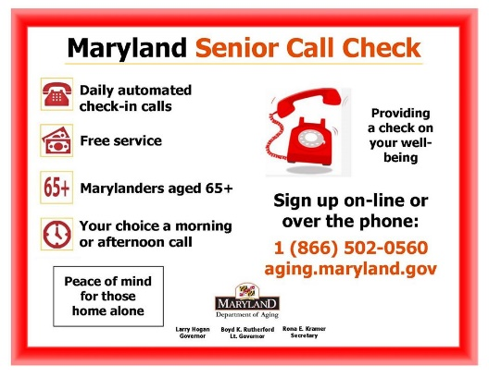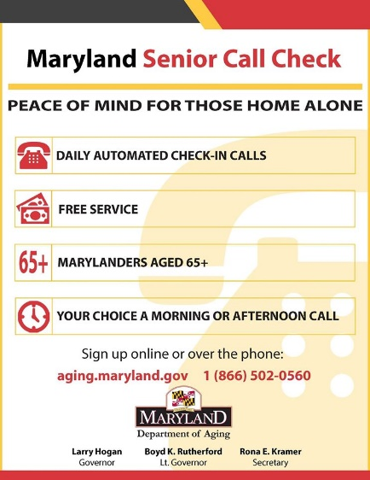
Suggested copy:
Senior Call Check is a FREE service available to adults 65+ in Maryland. Receive an automated daily call at a time you designate. After 3 attempts and no answer, we will contact your alternate person to check on you. Registration is easy – online or over the phone! https://aging.maryland.gov/Pages/senior-call-check.aspx
Twitter Copy:
Senior Call Check is a FREE service available to adults 65+ in #Maryland. Receive an automated daily call at a time you designate. After 3 attempts and no answer, we will contact your alternate person to check on you. Registration is easy! #marylandaging https://aging.maryland.gov/Pages/senior-call-check.aspx

