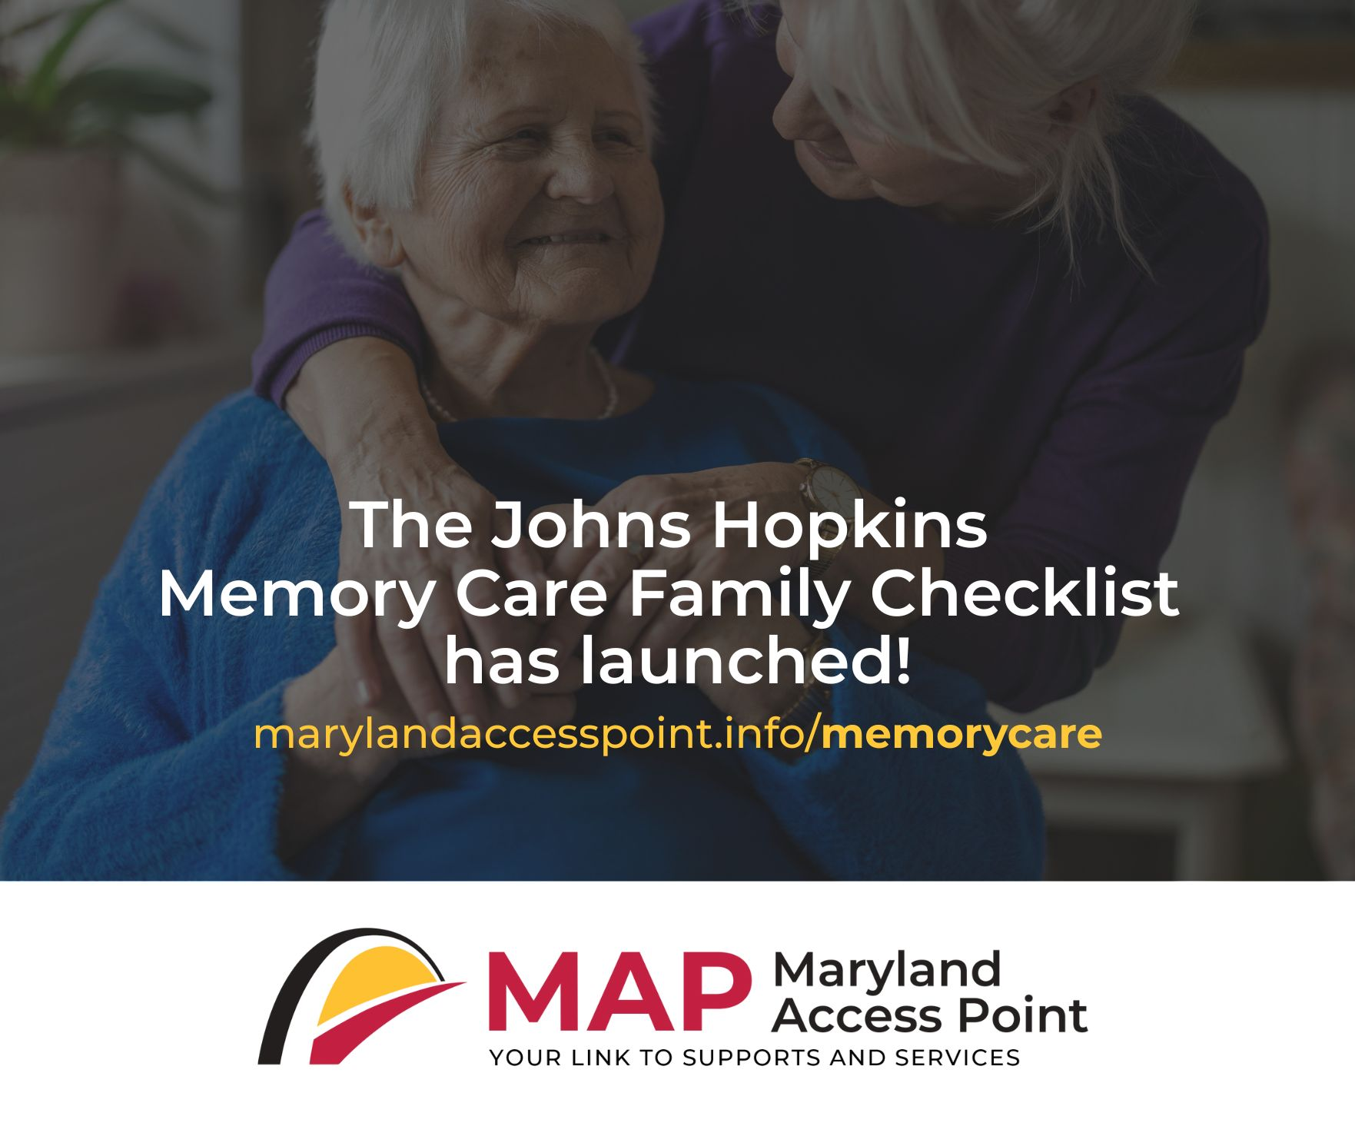
📣 It’s here! The Johns Hopkins Memory Care Family Checklist is now live—offering families a place to start after a memory loss diagnosis. This FREE, private tool helps caregivers identify their needs, organize their thoughts, and start to develop an action plan—without pressure or judgment. Caring for someone with cognitive issues can feel overwhelming. You don’t have to figure it out alone. Visit marylandaccesspoint.info/memorycare to connect with information and resources tailored to your family’s needs.


If you’re caring for someone living with dementia, it’s normal to feel unsure, stressed, and exhausted. Help is available—and knowing where to begin can make all the difference. The Johns Hopkins Memory Care Family Checklist supports Marylanders impacted by cognitive issues and their caregivers, offering tailored guidance, information, and available resources from local service providers.
Support for them. Support for you. 💙 Visit marylandaccesspoint.info/memorycare to get started on developing your care plan.


The Johns Hopkins Memory Care Family Checklist is an innovative resource that helps families caring for someone with cognitive challenges identify essential needs, access reliable information, and connect to supports to help develop a care plan. Key features:
✔️ Private, easy-to-use online tool
✔️ Personalized recommendations based on your situation
✔️ Focus on both care needs and caregiver wellbeing
✔️ Connections to trusted Maryland resources
Take the first step today at marylandaccesspoint.info/memorycare.

